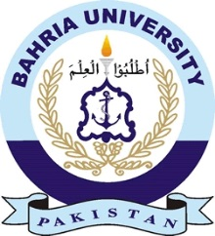

**Discovering Knowledge**

**DEPARTMENT OF SOFTWARE ENGINEERING**

**COURSE RESOURCES**

**FALL 2023**

**Web Engineering – SEN 310**

In the following link you can find:

* Schedule of the classes
* Course plan
* Lecture notes (pptx)
* Lecture codes
* eBooks

**Microsoft OneDrive Share**

https://pern-my.sharepoint.com/:f:/g/personal/adnanurrehman_bukc_bahria_edu_pk/Eh-EkQn8FexGmEd7IuKQsuQBQVDYaFDnRSs5_QZCV8h3xg?e=HCDqQO